**Introduction**

* + Strategy is a combination of end(goals) for which the form is striving and the means(policies) by which its seeking to get there.

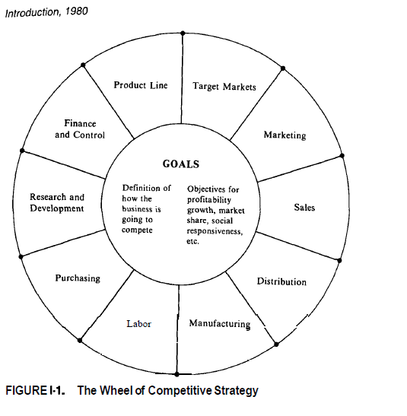

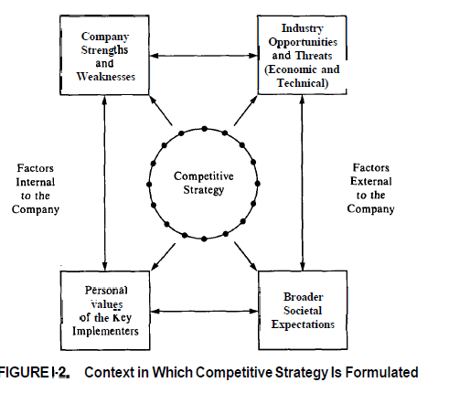

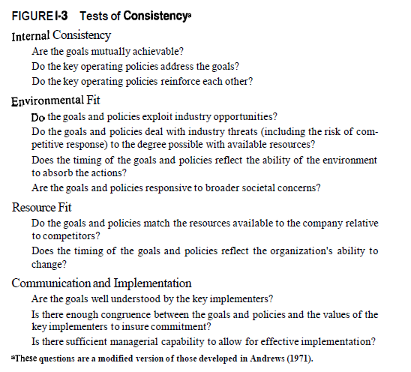

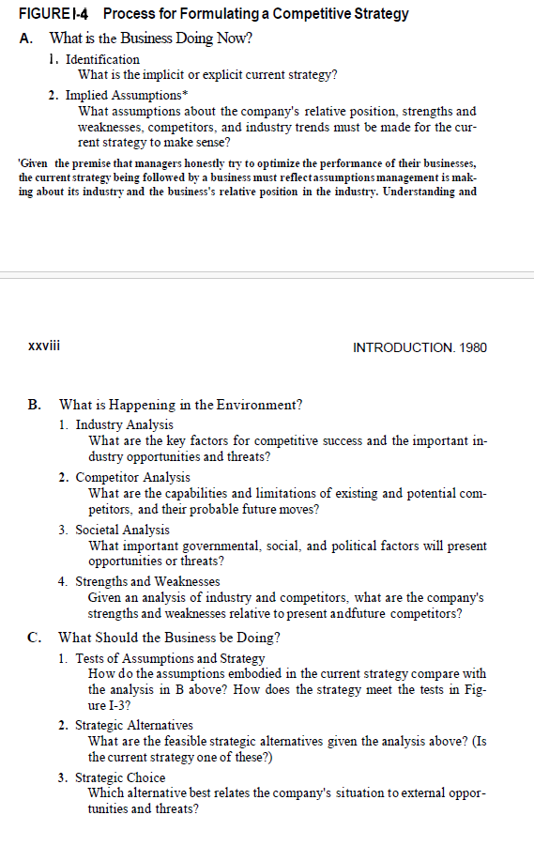

* + **Part 1: General Analytical Techniques**
  + **The Structural Analysis of Industry**

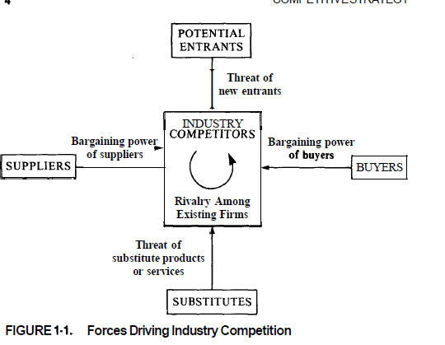

* + The free market return is approximated by long term return on government securities adjusted upward by risk of capital loss
  + Structural determinant of the intensity of competition
  + The threat of entry depends on barriers of entry and reaction from existing competitor.
    - Threat of entry
      * Barriers of entry
        + Economies of scale : if price reduces with scale , units sharing the resource
        + Product differentiation : branding, service etc.
        + Capital requirement
        + Switching cost
        + Access to distribution channel
        + Cost disadvantage independent of scale

Proprietary product tech

Favorable access to raw material

Favorable location

Government subsidy

Learning or experience curve

* + - * + Government policy
        + Expected retaliation

Depends on history

Established firm have resource

Established firms commitment

Slow industry growth

* + - * Entry deterring price : current price with expected cost of overcoming the entry barrier and retaliation
      * Entry barrier properties
        + Do change
        + Changes can be due to internal and external factor
        + Applies differently to different firm , some can overcome the barrier easier
      * Experience and scale as entry barrier
        + Limits of economy of scale

Tradeoff with product differentiation

Tech change may penalize

May lead to denial of new tech

* + - * + Experience is more ethereal entry barrier
        + Limit of experience

Nullified by new innovation

Trade off with product differentiation etc.

If more than one company is building strategy on experience, result can be fatal

Lead to Denial of new tech

* + - Intensity of rivalry between existing competitor
      * Numerous or equally balanced competitor
      * Slow industry growth
      * High fixed or storage cost
      * Lack of differentiation or switching cost
      * Capacity augmented in large increments
      * Diverse competitors
      * High strategic stake
      * High exit barrier
        + Specialized asset
        + Fixed cost of exit
        + Strategic interrelationship
        + Emotional barrier
        + Government or social restriction
      * The rivalry do shift /change
    - Exit barrier and entry barrier
    - 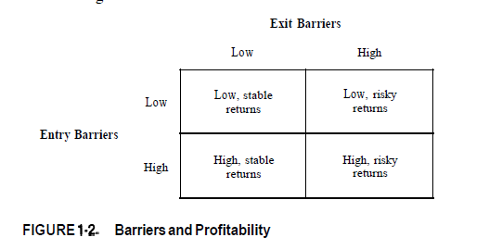
    - Pressure from substitute product
      * Below one need attention
        + If it improves price - performance tradeoff
        + If it is from a high profit earning industries
    - Bargaining power of buyer
      * It is concentrated or purchases large volumes relative to seller sell
      * Product it purchases represent significant fraction of buyer's cost or purchase
      * The product are standard or undifferentiated
      * Few switching cost
      * Earns low profit
      * Buyer pose a credible threat of backward integration
      * The industry product are unimportant to the quality of buyers product or service
      * Buyer has full information
    - Altering buyer power / buyer selection
    - Bargaining power of suppliers
      * Dominated by few companies and more concentrated than the industry it sells to
      * Not obliged to contend with other substitute product
      * Industry is not an important customer to supplier
      * Supplier's product is an important input to buyers business.
      * Product is differentiated or it has built switching cost
      * Supplier possess a credible threat of forward integration
    - Government as a force in industry competition
      * Government is supplier/ buyer
      * Government can push substitute through regulation, subsidy etc.
    - Competitive strategy(offensive/ defensive) have below approaches
      * Positioning: to provide the best defense against the competitive force
      * Influence the balance: of forces through strategic moves to improve relative position
      * Exploiting change: Anticipate shift and respond to them before rival
    - Diversification strategy
  + Generic competitive strategy
    - Overall cost leadership
    - Differentiation : brand image, tech, feature, customer service, dealer network
    - Focus
  + 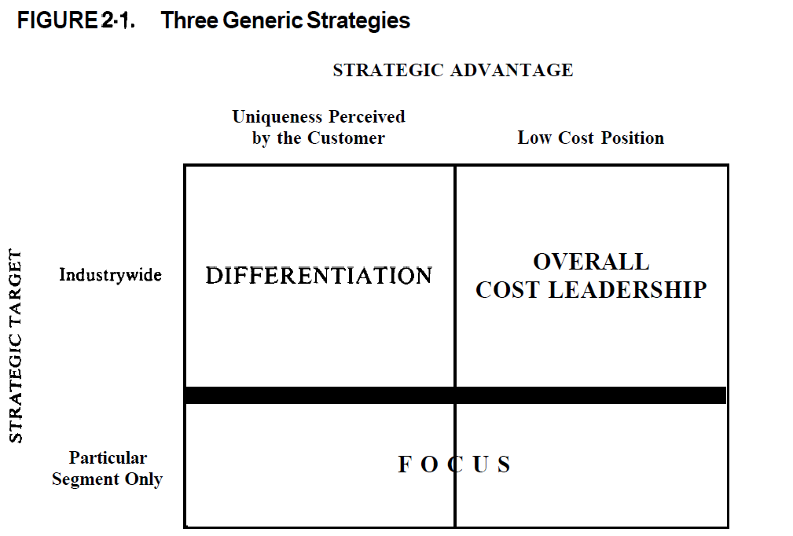

* + 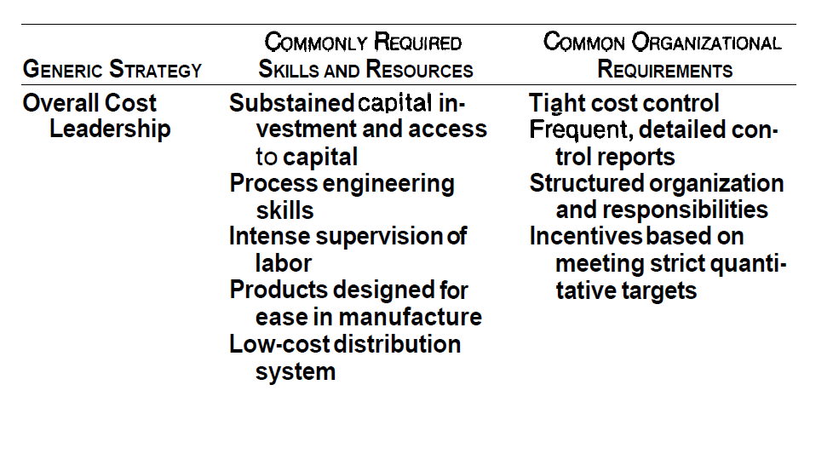

* + 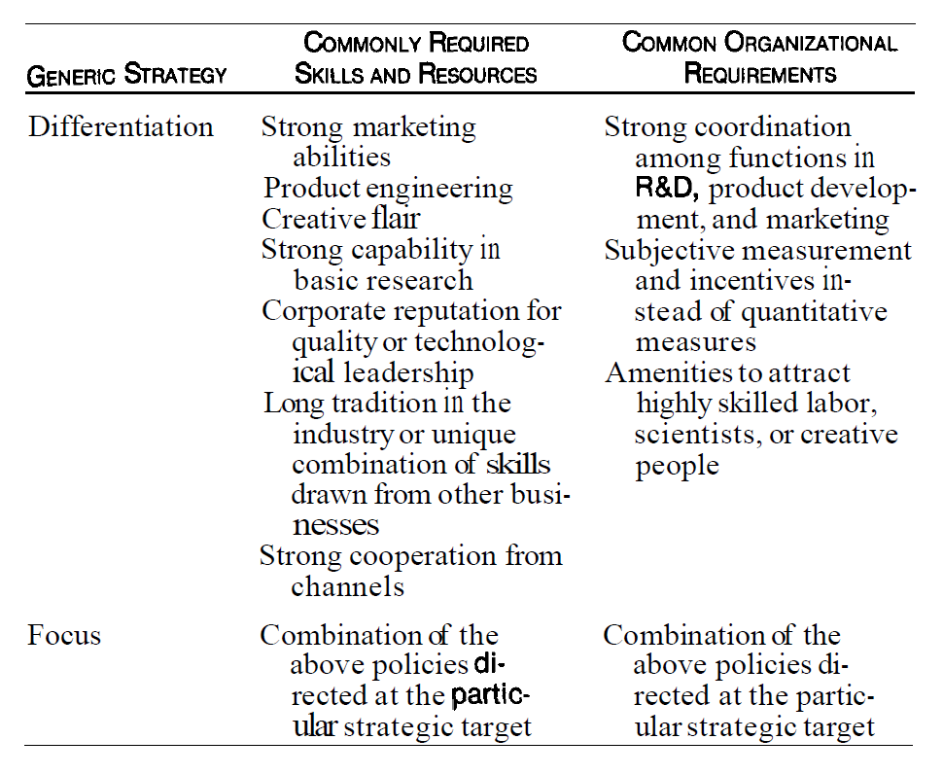

* + Avoid being stuck in the middle
  + 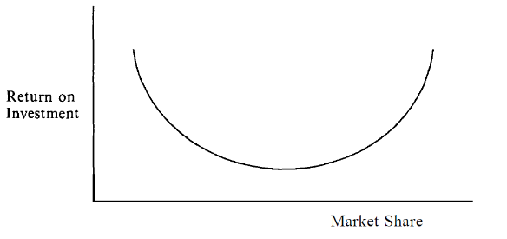

* + Risk of generic strategy
    - Cost leadership
      * Tech change nullify past investment and experience
      * Imitation : leads to low cost learning for newcomers
      * Denial to see product or marketing change due to attention on cost
      * Focus on cost reduces ability for branding and other differentiation approaches
    - Differentiation
      * High cost
      * Buyer become more sophisticated
      * imitation narrows differentiation
    - Focus
      * Cost
      * Narrow target
      * Other Competitor target this focus segment
  + A framework for competitive analysis
    - 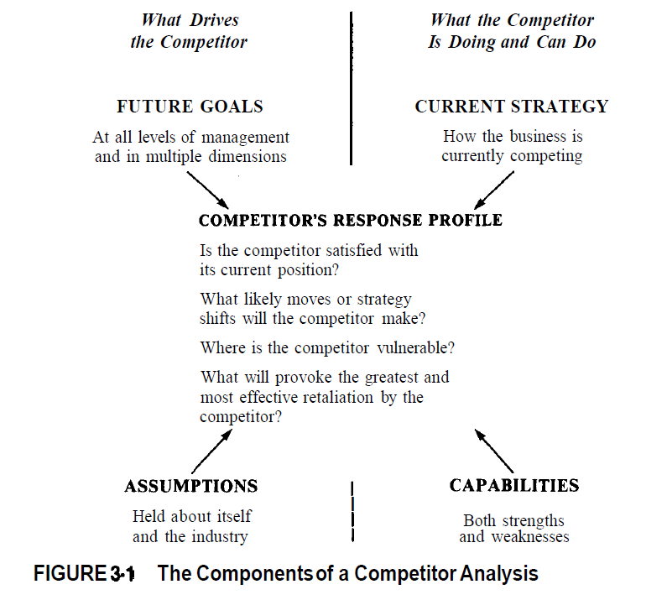

* + All existing and potential competitor should be analyzed
  + Potential competitor
    - Firm not in industry but can easily overcome entry barrier
    - Firms having obvious synergy to be in the industry
    - Firms for whom competing in the industry is an extension of corporate strategy
    - Backward or forward integration candidate
    - Merger and acquisition
  + Future goals
    - Business unit goals (study below)
      * Tradeoff : Choice between growth and profit etc.
      * Attitude towards risk
      * Belief
      * Org structure
      * Control and incentive system
      * Accounting system
      * Types of managers in leadership(cxo)
      * Unanimity among managers
      * Composition of board
      * Contractual commitment
      * Government regulatory constraint
    - The corporate parent and business unit goal
      * Current result
      * Overall goal of parent
      * Strategic importance of the BU for the parent
      * Why parent got into this business
      * Economic relationship between parent and BU
      * Corporate wide value and belief
      * Any generic strategy that parent applies for other business
      * Performance and need of other unit
      * Parents diversification plan
      * Organizational structure
      * Compensation and incentive
      * What executives are being rewarded
      * Where are they recruit from
      * Any social or government regulation sensitivity
      * Emotional attachment
  + Portfolio analysis and competitors goals
    - Business classification criteria at parent level
    - Which business are counted as cash cows
    - Which business is candidate for harvest/divestment
    - Which business balances the portfolio
    - Business with defensive mood
    - Business with most promising area
    - Business with lot of leverage
  + Competitor goal and strategic positioning
    - Assumption
      * About itself
      * About industry and other competitor
    - Question to identify competitor assumption
      * Believe about relative position in cost , quality etc.
      * Historical and emotional identification
      * Cultural, regional and national differences
      * Org values and canons
      * Belief of Future demand and significance of industry trend
      * Estimation of competitors goal etc.
      * Belief on historic wisdom and new market condition
      * Current strategy
  + The significance of perceiving blind spot or conventional wisdom
  + History as indicator of goal and assumption
    - Current performance relative to recent past
    - History in marketplace overtime
    - What area it succeeded
    - How it reacted to past strategic moves
  + Managerial background and advisory relationship
    - Functional background
    - Types of strategy that worked /not worked for them in past
    - Other business they have worked in
    - Major events they have lived through
    - Perspective gained from their writing and speaking
    - Consulting firm, agency used by the company
  + Current strategy
  + Capability
  + 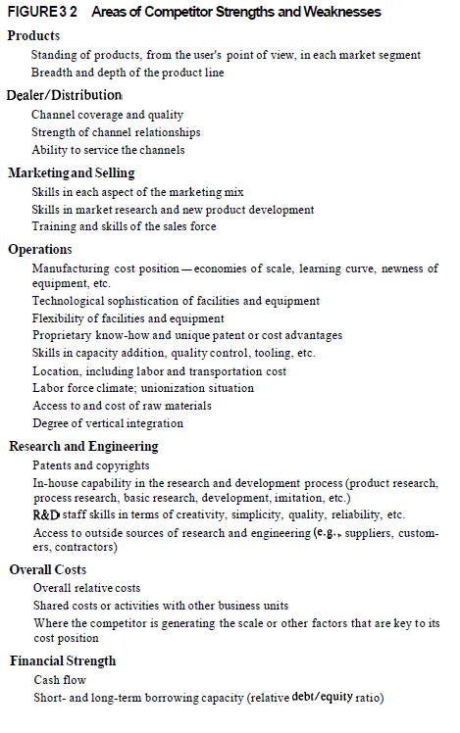

* + 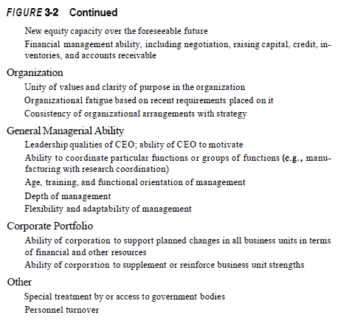
  + Read question on below capability from book (page 94)
    - Core capability
    - Ability to grow
    - Quick response capability
    - Ability to adapt to change
    - 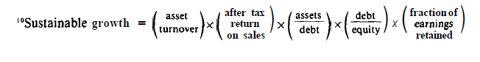
    - Staying power
  + Competitor's profile on how he would respond
    - Offensive
      * Satisfaction with the current position
      * Probable moves
      * Strength and seriousness of moves
    - Defensive
      * Vulnerability
      * Provocation
      * Effectiveness of retaliation
  + 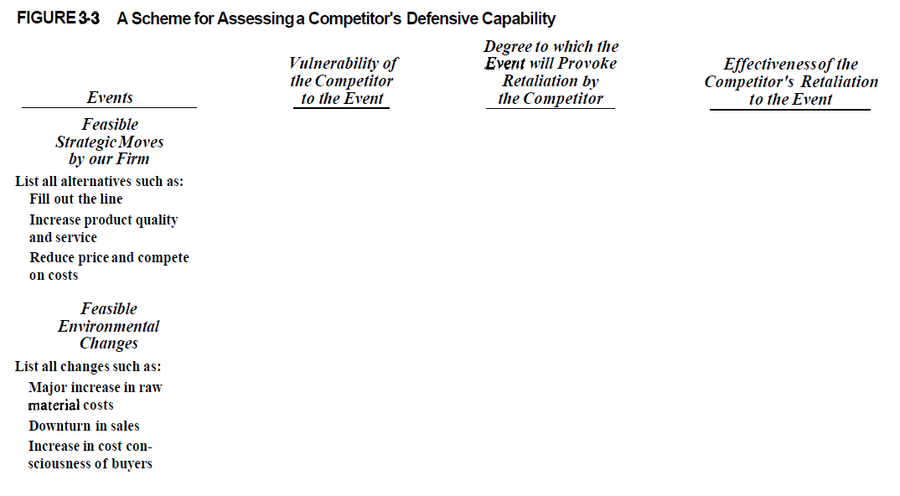
  + Picking the battleground
    - Putting competitor in situation of conflicting goals
  + Competitors analysis and industry forecasting
  + The need for competitor intelligence system
  + 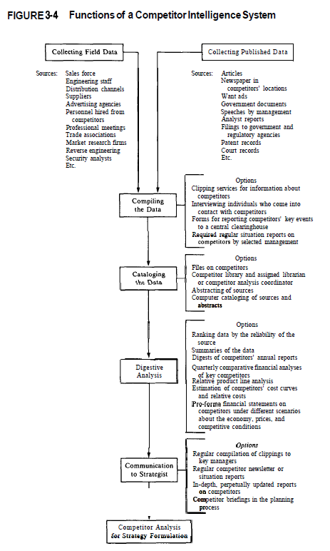
  + Market Signals
    - Types of market signal
      * Prior announcement of moves
        + Ex. Capacity expansion, Preemption, threats, test of competitor's sentiment
        + Communicating pleasure/displeasure, minimize the provocation
        + Avoiding costly simultaneous moves
        + Communicating with financial community
        + Internal support
        + Means to do

Official press release

Interviews

Speeches

* + - * Announcement of action or result after the fact
      * Public discussion of industry by competitor
      * Competitors discussion and explanation of their own moves
      * Competitors tactics relative to what they could have done
      * Manner in which strategic changes are initially implemented
      * Divergence from past goals
      * Divergence from industry precedence
      * Cross parry
      * The fighting brand
      * Private antitrust suit
    - Use of history in identifying market signals
    - Can market signals be distracting
  + Competitive moves
    - Classic prisoner's dilemma
    - Industry instability : the likelihood of competitive warfare
    - Competitive moves
      * Cooperative or non-threatening moves
        + Move that strengthen the firms position and competitor's position, even if they don't match them
        + Move that strengthen the firm's position and competitors position, if a significant number of them matches them
        + Move that improve firms position because competitors will not match them
      * Moves will be perceived as non-threatening if
        + Competitor don’t notice
        + Competitors will not be concerned because of their self-perception or assumption
        + Competitors performance is impaired little if measured by their criteria
    - In some industries, some firms take the leadership role , other follow it for prices and other strategies
    - Threatening Moves
      * Questions in considering threatening moves
        + How likely is retaliation
        + How soon will retaliation come?
        + How effective will retaliation be ?
        + How tough?
        + Can retaliation be influenced ?
      * Lags in retaliation
        + Perpetual lag
        + Lag in mounting the strategy
        + Inability to pin point retaliation
        + Lag caused by conflicting goals
    - Defensive moves
      * Discipline as form of defensive move
      * Denying a base : involves price war, heavy R&D
    - Commitment
      * Commitment that firm will stick to the move its making
      * Commitment that firm will retaliate
      * Commitment that firm will take no action
    - Communicating commitment
      * Asset , resource
      * Clear intention
      * Inability to back down
      * Ability to detect compliance to the term to which commitment refers
      * Trust as a commitment
    - Focal point: industry will come to a point where it will stick as it serves everybody's purpose
    - Information secrecy: selective disclosure
  + Strategy towards buyers and suppliers
    - Buyer selection
      * Framework for buyer selection
        + Purchasing need vs company capability
        + Growth potential

Industry growth

Market segment growth

% share in market segment

* + - * + Structural position

Good buyer

They purchase small quantity compared to firms capacity

They lack quality alternative

Face high shopping transaction and negotiation cost

Lack credible threat of backward integration

High switching cost

Price sensitivity of buyer

Cost of product is small compared to buyers budget

Penalty of product failure is high compared to cost

Effectiveness of product can yield major savings

Purchased product help in high strategic competition

buyer seek custom design

Buyer is very profitable

Buyer is poorly informed

Motivation of actual decision maker is not narrowly defined as cost saving

* + - * + Cost of serving

Order size

Direct vs distributor

Required lead time

Steadiness of order flow , for planning

Shipping cost

Selling cost

Need for customization or modification

* + - Buyer selection and strategy
      * Firm with low cost position can sell to powerful price sensitive buyer and still be successful
      * Firm without cost advantage and differentiation must be selective about buyer
      * Good buyers can be created through strategy : ex switching cost etc.
      * The basis of buyer choice can be broadened : by providing value added svc
      * High cost buyer can be eliminated
      * Quality of buyer can change over time
      * Switching cost should be considered in the startegy
    - Purchasing strategy
      * Key issues
        + Stability and competitiveness of supplier pool
        + Optimal degree of vertical integration
        + Allocation of purchases among qualified supplier
        + Creation of maximum leverage with chosen supplier
      * Supplier is powerful, if
        + Concentration of supplier
        + Lack of dependence on customer for a substantial fraction of sales
        + Switching cost facing customer
        + A unique or differentiated product
        + Threat of forward integration
        + Buyer lack backward integration threat
        + Buyer face high info , negotiation cost
      * Spread purchases
      * Avoid switching cost
      * High quality alternate source
      * Promote standardization
      * Create a threat for backward integration
      * Use of tapered integration
  + Structural analysis within industry
    - Dimension of competitive strategy
      * Specialization
      * Brand identification
      * Push vs pull
      * Channel selection
      * Product quality
      * Tech leadership
      * Vertical integration
      * Cost position
      * Service
      * Price policy
      * Leverage : reln with parent company
      * Reln with host and home government
    - Strategic group
      * 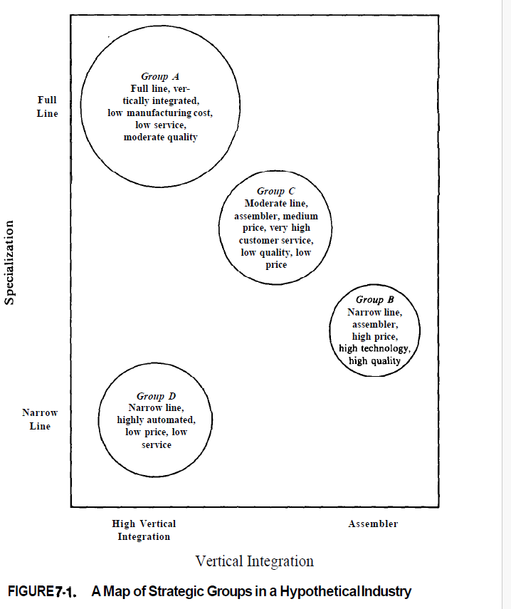
    - Strategic groups and mobility barriers
    - Mobility barrier and group formation
    - Strategic group and bargaining power
    - Strategic group and threat of substitute
    - Strategic group and rivalry among firms
    - Factors determining strategic group rivalry
      * Market interdependence
      * Product differentiation
      * No of group and their sizes
      * Strategic distance among group
    - 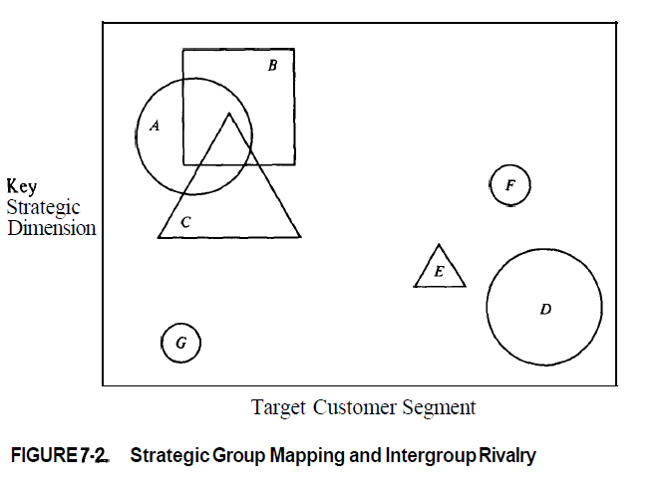

* + Strategic group and firms profitability
    - Common industry characteristic
    - Characteristic of strategic group
      * Mobility barrier
      * Bargaining power
      * Substitute product
      * Rivalry exposure
    - Firm position within strategic group
      * Competition
      * Scale
      * Cost of entry
      * Ability of firm to execute
  + Are big firms more profitable than small firms
  + 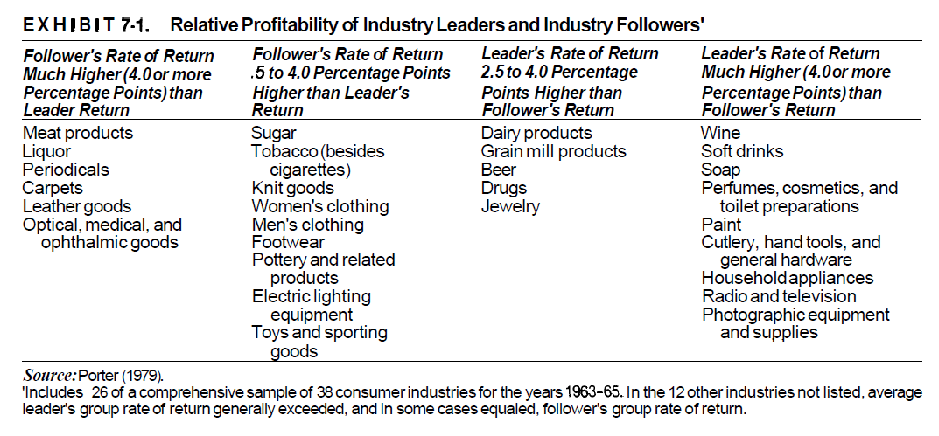

* + 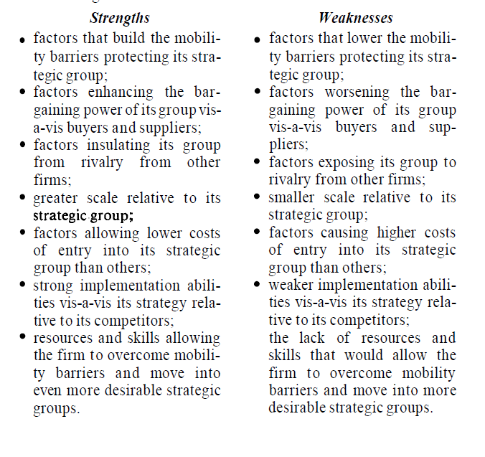
  + Strategic opportunity
    - Create a new strategic group
    - Shift to a favorable group
    - Strengthen position in group
    - Shift to a group and strengthen its position
  + Risk identification
    - Risk of other firm entering the group
    - Risk of reducing mobility barriers
    - risks that accompany investments designed to improve the firm's position by increasing mobility barriers;
    - risks of attempting to overcome mobility barriers into more desirable strategic groups or entirely new groups.
  + 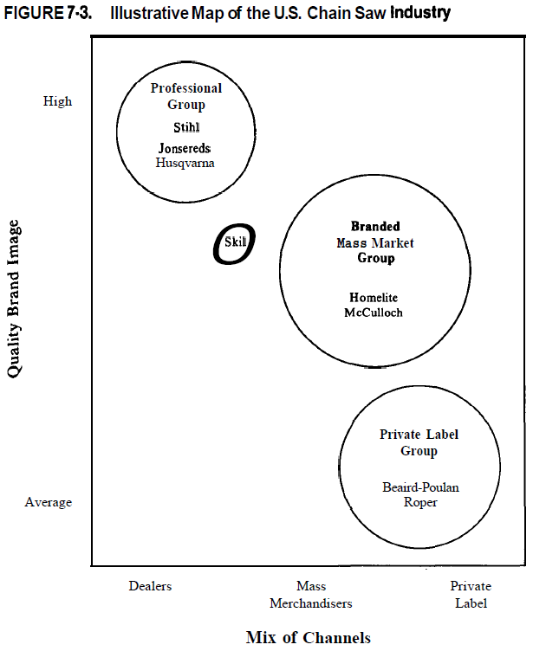
  + Strategic group map help in below
    - Identify mobility barrier
    - Identify marginal group
    - Charting direction of strategic movement
    - Analyzing trend
    - Predicting reaction
  + Industry evolution
    - Basic concept
      * Product life cycle
        + 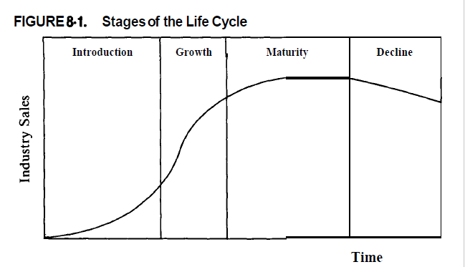
        + Duration varies
        + Its not always s shaped
        + 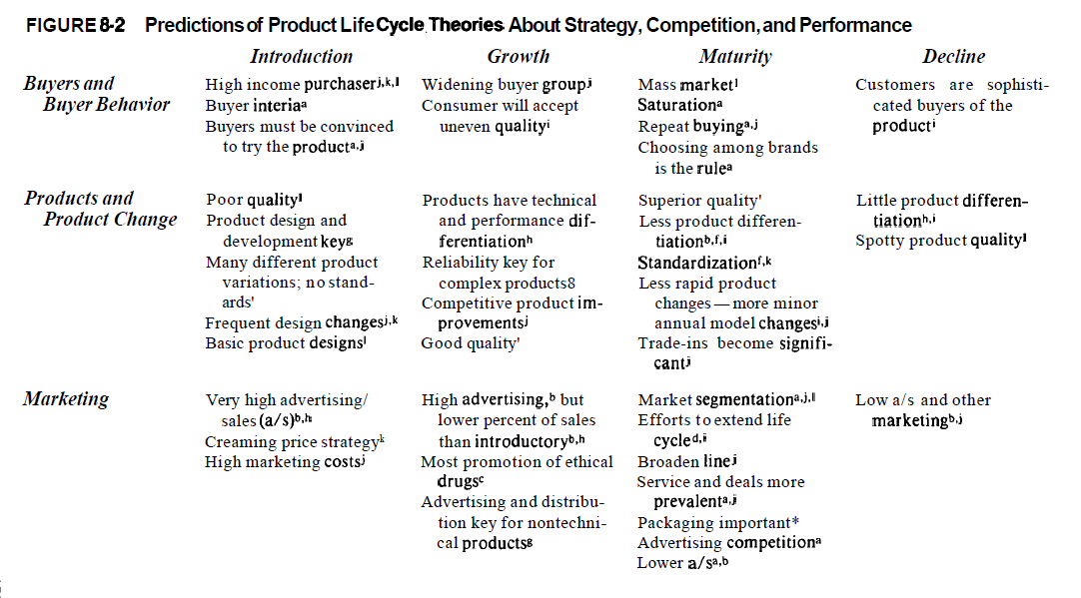

* + 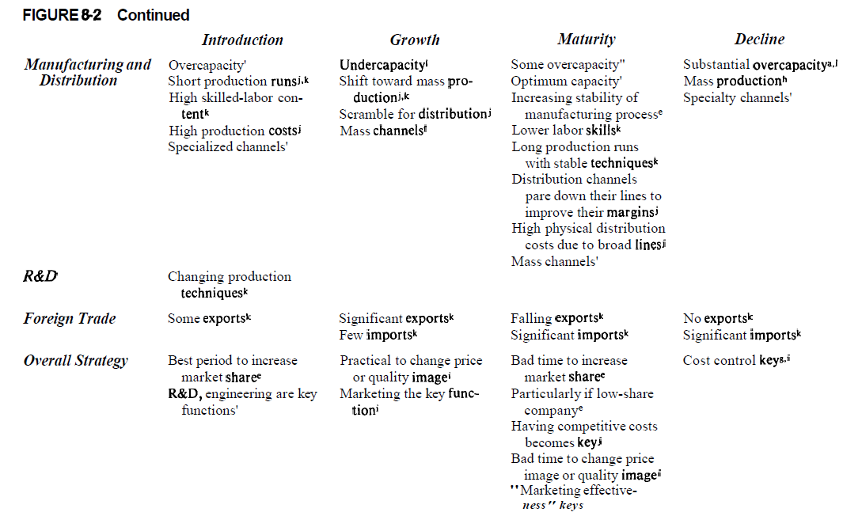

* + 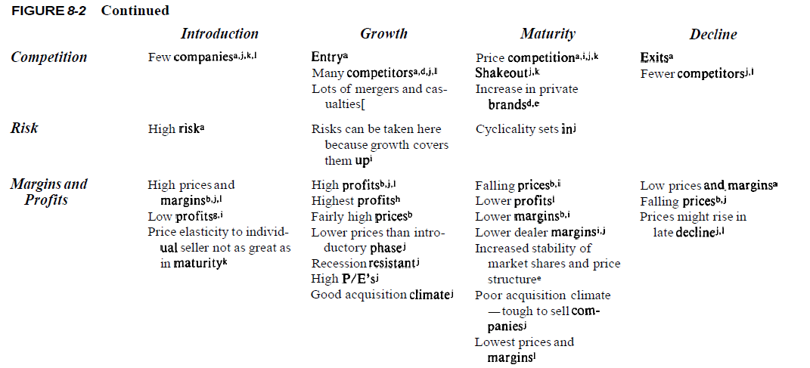
  + Framework for forecasting evolution
  + Evolutionary process
    - Long run change in growth, Demography
      * Trend change
      * Change in relative position of substitute
      * Change in relative position of complementary product
      * Penetration of customer group
      * Product change
    - change in buyer segment
    - buyer learning : become more like commodity
      * 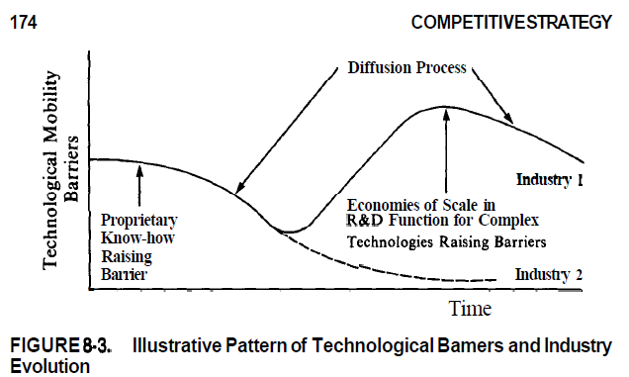
    - Reduction in uncertainty
    - Diffusion of proprietary knowledge
    - Accumulation of experience
    - Expansion or contraction in scale
    - Change in input cost
      * `wage, material, capital, communication, transport
    - Product innovation
    - Marketing innovation
    - Process innovation
    - Structural change in adjacent industry
    - Government policy change
    - Entry and exit
  + Key relation in industry evolution
    - Will industry consolidate
      * Industry consolidation and mobility barrier move together
      * No concentration if mobility barriers are low or falling
      * Exit barriers deter consolidation
      * Long run profit potential depends on future structure
    - Changes in industry boundary
      * 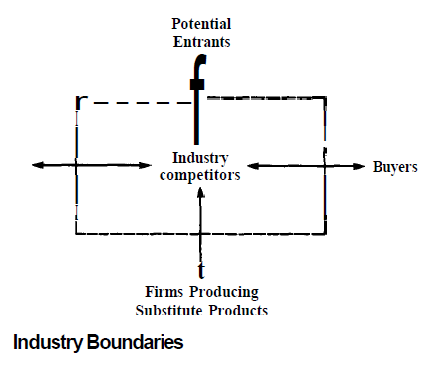
  + Firms can influence industry structure

**PART 2: GENERIC INDUSTRY ENVIRONMENT**

* + Competitive strategy in fragmented industry
    - Service, retail, distribution, wood and metal fabrication, agricultural products, creative business
    - What makes industry fragmented
      * Low entry barrier
      * Absence of economies of scale
      * High transport cost
      * High inventory cost or erratic sale fluctuation
      * No advantage of size in dealing with buyer/ supplier
      * Diseconomy of scale in some cases
      * Diverse market need
      * High product differentiation , based on image
      * Exit barriers: high
      * Local regulation
      * Government prohibition of concentration
      * Newness
    - Overcoming fragmentation
      * Create economies of scale
      * Standardize market need
      * Neutralize the aspect responsible for fragmentation
      * Make acquisition
      * Recognize industry trade early
    - Industry that are stuck
      * Existing firm lack skill/resource
      * Existing firm are myopic
      * Lack of attention by outside firm
    - Coping with fragmentation
      * Tightly managed decentralization
      * Formula facility
      * Increase value added
      * Specialization by product type or product segment
      * Specialization by customer type
      * Specialization by order type
      * Focused geographic area
      * Bare bone /no frill
      * Backward integration
    - Potential strategic trap
      * Seeking dominance
      * Lack of discipline
      * Over centralization
      * Assumption that competitor have same overhead and objective
      * Overreaction to new product
    - 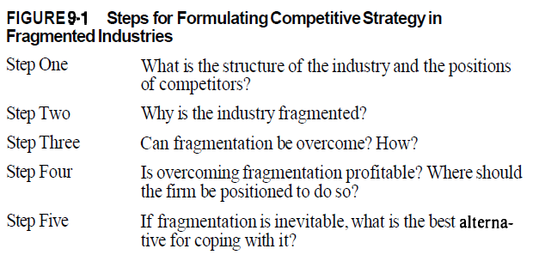
  + Competitive strategy in emerging industry
    - The structural environment
      * Common structural characteristic
        + Tech uncertainty
        + Strategic uncertainty
        + High initial cost but steep cost reduction
        + First time buyers
        + Short time horizon
        + Subsidy
      * Early mobility barrier
        + Proprietary tech
        + Access to distribution channel
        + Access to raw material
        + Cost advantage due to experience
        + Risk, capital barrier
      * Problems constraining industry development
        + Inability to obtain raw material and component
        + Period of rapid escalation of raw material price
        + Absence of infrastructure
        + Absence of product and tech standardization
        + Perceived likelihood of obsolescence
        + Customer's confusion
        + Erratic product quality
        + Image and credibility with financial community
        + Regulatory approval
        + High cost
        + Response of threatened entities
        + 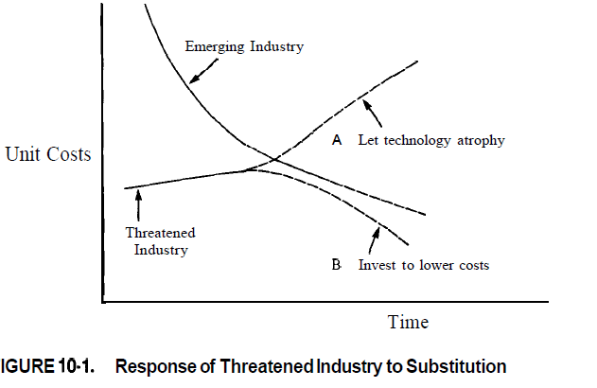
      * Early and late markets (decided on below points)
        + Nature of the benefit

Performance advantage

Cost advantage

* + - * + State of art required to yield significant benefits
        + Cost of product failure
        + Introduction of switching cost
        + Support service
        + Cost of obsolesce
        + Asymmetric government , regulatory, or labor barriers
        + Resource to change
        + Perception of tech change
        + Personal risk to decision maker
      * Strategic choice
        + Shaping industry structure
        + Externalities in industry development
        + Changing role of supplier and channels
        + Shifting mobility barriers
      * Timing entry
        + Appropriate

Image is important and pioneer can create image

Learning curve is imp

Customer loyalty is important

Early commitment to supplier, channel

* + - * + Risky

Early competition

Cost of opening market is huge

Early competition is costly

Tech change will obsolete things

* + - * + Tactical move

Early commitment to supplier

Timing financing

* + - * Coping with competitor
      * Technique for forecasting
      * 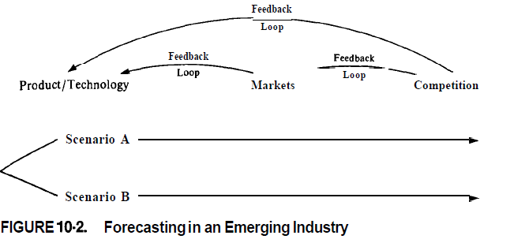

* + Which emerging industry to enter
  + Transition to industry maturity
    - Industry change during transition
      * Slowing growth means more competition for market share
      * Firms in industry increasingly are selling to experienced repeated buyer
      * Competition shift towards greater emphasis on cost and service
      * Topping out problem in adding industry capacity and personal
      * Manufacturing, marketing, distribution, selling and research methods are often undergoing change
      * New products or application are harder to come by
      * International competition increase
      * Industry profit often fall during transition period, temp or permanent
      * Dealers margin fall but their power increase
    - Some strategic implication of transition
      * Overall cost leadership vs differentiate vs focus
        + Sophisticated cost analysis

Rationalizing the product mix

Correct pricing

* + - * Process innovation and design for manufacture
      * Increasing scope of purchases
      * Buy cheap assets
      * Buyer selection
      * Different cost curves
        + 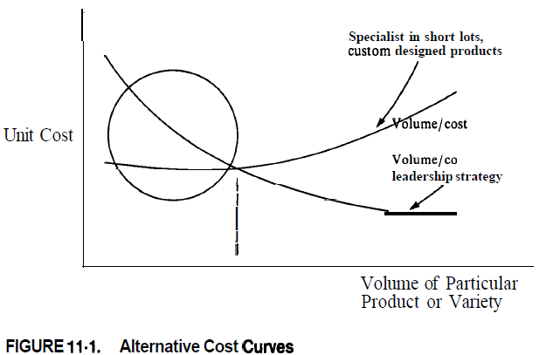

* + Competing internationally
  + Should transition be attempted at all
  + Strategic pitfall in transition
    - Company's self perception and perception of industry
    - Caught in middle
    - Cash trap
    - Giving up market share too easily in favor of short term profit
    - Resentment and irrational reaction to price competition
    - Resentment and irrational reaction to change in industry practice
    - Over emphasis on creative new products rather than improving aggressive selling existing once
    - Clinging to high quality as an excuse for not meeting aggressive pricing and marketing moves
    - Overhanging excess capacity
  + Organizational implication on maturity
    - Scale down expectation for financial performance
    - More discipline from organization
    - Scale down expectation for advancement
    - More attention on human dimension
    - Recentralization
  + Industry transition and general manager
    - Unfortunate outcome
      * Denies transition
      * Leaves active management
  + Competitive strategy in declining industry
    - Structural determinant of competition in decline
      * Condition of demand
        + Uncertainty
        + Rate and pattern of decline
        + Structure of remaining demand pocket
      * Causes of decline
        + Tech substitution
        + Demographics
        + Shift in needs
      * Exit barriers
        + Durable and specialized assets
        + Fixed cost of exit
        + Strategic exit barrier

Interrelatedness

Access to financial market

Vertical integration

* + - * Info barrier
      * Managerial and emotional barrier
      * Govt and social barriers
      * Mechanism for asset disposition
        + Volatility of rivalry

Product is perceived as commodity

Fixed cost are high

Many firms are locked due to high exit barrier

Relative strength of firm are same

* + - Strategic alternative in declines
    - 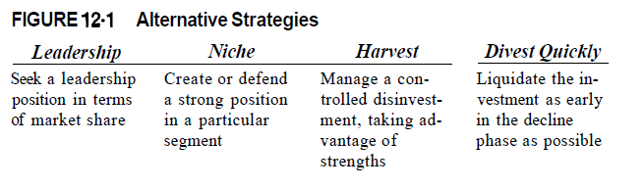
    - Leadership
      * Aggressive competition
      * Acquire competitor
      * Purchase retiring competitor capacity
      * Reducing competitor exit barrier
      * Demonstrate strong commitment
      * Demonstrate superior strength
      * Develop and disclose credible information
      * Raise the stake for competitor
    - Harvest
      * Reduce number of models
      * Shrinking the number of channel
      * Eliminate small customer
      * Eroding service in delivery, repair time
    - Choose a strategy for decline
      * Question
        + Industry: hospitable , potential profitable
        + Competitors : exit barriers, leader etc.
        + Firms relative strength
      * 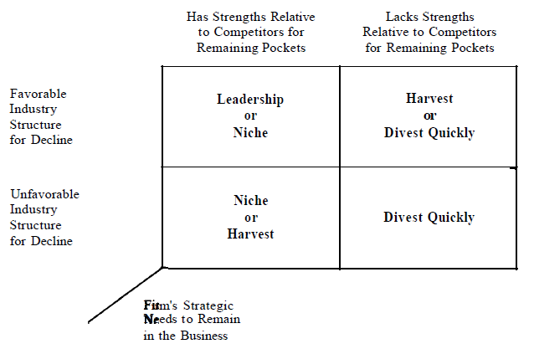
    - Pitfalls in decline
      * Failure to recognize decline
      * A war of attrition
      * Harvesting without clear strength
    - Preparing for decline
      * Minimize investment
      * Target favorable market segment
      * Create switching cost
  + Competition in global market
    - Factors leading to
      * Cost difference in country
      * Deferring circumstance in foreign market
      * Different roles of foreign govt
      * Diff in role, resource and ability to monitor foreign competitor
    - Impediment to global competition
      * Licensing, export , FDI
    - Source of global competitive advantage
      * Comparative advantage
      * Production economies of scale
      * Global experience
      * Logistical economies of scale
      * Marketing economies of scale
      * Economies of scale in purchasing
      * Product differentiation
      * Proprietary product tech
      * Mobility of production
    - Impediment to global competition
      * Economic impediment
        + Transportation and storage cost
        + Differing product needs
        + Established distribution channel
        + Sales force
        + Local repair
        + Sensitivity to lead times
        + Complex segmentation within geographic markets
        + Lack of world demand
      * Managerial impediment
        + Differing marketing task
        + Intensive local service
        + Rapidly changing tech
      * Institutional impediment
        + Govt impediment
    - Evolution to global industries
      * Env triggers to globalization
        + Increased sale economies
        + Decreased transportation or storage cost
        + Rationalized or changed distribution channel
        + Changed factor cost
        + Narrowed national economies and social circumstance
        + Reduced government constraint
      * Strategic innovations simulating globalization
        + Product redefinition
        + Identification of market segment
        + Reduced cost of adaptation

Design change

Disintegration of production

Elimination of constraints from resources or perception

* + - Competition in global industry
      * Industrial policy and competitive behavior
      * Relationship with host government in major markets
      * Systemic competition
      * Difficulty in competitor analysis
      * Strategic alternative in global industries
        + Broadline global competition
        + Global focus
        + National focus
        + Protected niche
      * Trends affecting global competition
        + Reduction in difference among countries
        + More aggressive industrial policy

**PART 3 : strategic decision**

* + **Strategic analysis of vertical integration**
    - **Strategic benefits and cost of vertical integration**
      * **Volume of throughput versus efficient scale**
    - **Strategic benefit of integration**
      * **Economies of integration**
      * **Economies of combined operations**
      * **Economies of internal control and coordination**
      * **Economies of information**
      * **Economies of avoiding the market**
      * **Economies of stable relationship**
    - **Characteristic of vertical integration economies**
      * **Tap into tech**
      * **Assured supply or demand**
      * **Offset bargaining power and input cost distortion**
      * **Enhanced ability to differentiate**
      * **Elevate entry and mobility barrier**
      * **Enter a high return business**
      * **Defend against foreclosure**
    - **Strategic cost of integration**
      * **Cost of overcoming mobility barrier**
      * **Increased operating leverage**
      * **Reduced flexibility to change partners**
      * **Higher exit barrier**
      * **Capital investment requirement**
      * **Foreclosure of access to supplier or consumer research and/or know how**
      * **Maintaining balance**
      * **Dulled incentive**
      * **Differing managerial requirement**
    - **Particular strategic issue in forward integration**
      * **Improved ability to differentiate the product**
      * **Access to distribution channel**
      * **Better access to market information**
      * **Higher price realization**
    - **Particular strategic issue in backward integration**
      * **Proprietary knowledge**
      * **Differentiation**
    - **Long term contract and economies of integration**
      * **Some economies can be gained by contract without capex**
    - **Tapered integration (Half integration)**
    - **Quasi integration : building reln with vertical integration** 
      * **Equity investment**
      * **Loan or loan guarantee**
      * **Purchase credit**
      * **Exclusive dealing agreement**
      * **Specialized logistic facility**
      * **Cooperative R&D**
    - **Illusion in vertical integration decision**
      * **Strong market position in one can be extended to other**
      * **Its always cheaper to do internally**
      * **Its often makes sense to integrate into cooperative business**
      * **Vertical integration can save sick business**
      * **Experience in one applies to other**
    - **Keep the entities separate, otherwise loss of interest due to unfair measurement**
  + Capacity expansion\
    - 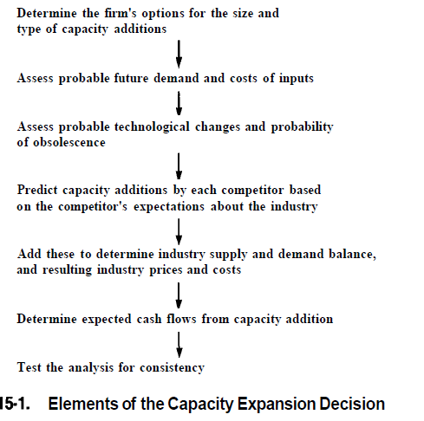
    - Cause of overbuilding capacity
      * Cyclic demand
      * No product differentiation
      * Tech
        + Adding capacity in large lumps
        + Economies of scale and significant learning curve
        + Long lead time in adding capacity
        + Increased minimum efficient scale(MES)
        + Change in production tech
      * Structural
        + Significant exit barrier
        + Building credibility
        + Integrated competitors
        + Capacity share affects demand
        + Age and type of capacity affects demand
      * Competitive
        + Large number of firms
        + Lack of credible market leader
        + New entry
        + First mover advantage
      * Information flow
        + Inflation of future expectation
        + Divergent assumption or perception
        + Breakdown of market signaling
        + Structural change
        + Financial community pressure
      * Managerial
        + Production orientation of management
        + Asymmetric aversion to risk
      * Governmental
        + Perverse tax incentive
        + Desire for indigenous industry
        + Pressure to increase or maintain employment
    - Limits to capacity expansion
      * Financing constraint
      * Company diversification
      * Etc.
    - Preemptive strategy
      * 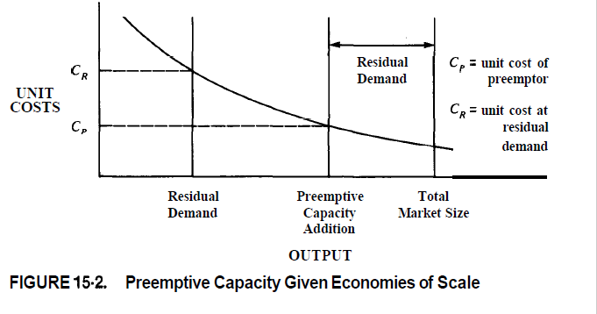
    - Credibility of preemptive firm
    - Ability to signal before others act
    - Willingness of competitor to back down
  + Entry into new business
    - Entry through internal development
      * Capex
      * Entry barrier
      * Cost to withstand retaliation
      * Expected cash flow from being in industry
    - Will retaliation occur
      * Commodity like product
      * High fixed cost
      * High industry concentration
      * Competitor who attach high strategic importance
      * Management attitude
    - Identifying target industry for internal entry
      * The industry in disequilibrium
        + New industry
        + Rising entry barrier
        + Poor information
      * Slow or ineffective retaliation
        + Retaliation cost outweigh benefit
        + Parental dominance
      * Lower entry cost
      * Ability to influence industry structure
      * Positive effect on existing business
    - Generic concept for entry
      * Reduced product cost
      * Buy in with low price
      * Offer a superior product
      * Discover new niche
      * Introduce marketing innovation
      * Piggybacking distribution
    - Entry through acquisition
      * Profitable
        + Low price acquisition
        + Imperfect market
        + Buyer has unique ability to operate in that industry
    - Sequenced entry : first into private level. Then move to branding etc.
  + APPENDIXES
  + A:protfolio technique in competitor analysis
    - 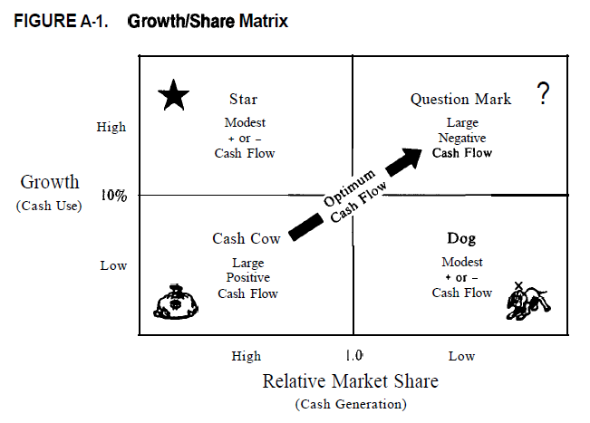

* + 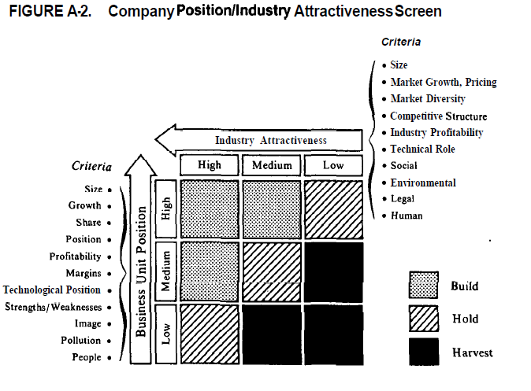

* + B: HOW TO CONDUCT INDUSTRY ANALYSIS
    - Who is in the industry
    - 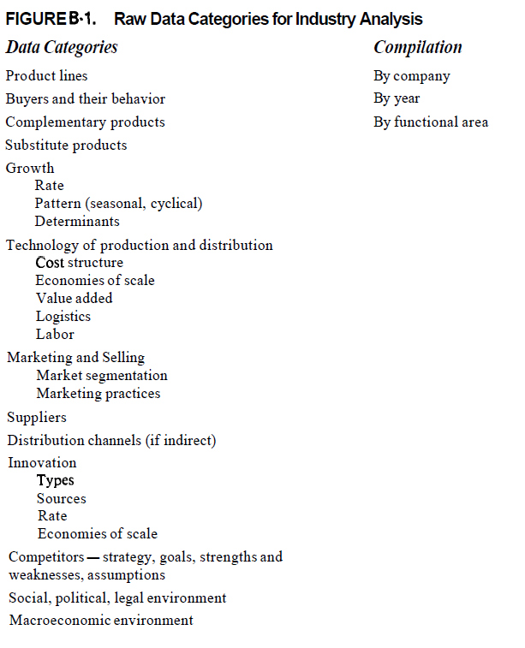
    - Industry study
    - Annual report
    - Get into field early
      * Get over the hump
  + Published sources for analysis of industry and competitor
    - Industry studies
    - Trade associations
    - Trade magazines
    - Business press
      * Company directory and statistical data
      * Company docs
      * Major government sources
      * Other sources
        + Tax record
        + Local news
        + Antitrust record
  + Gathering field data
  + 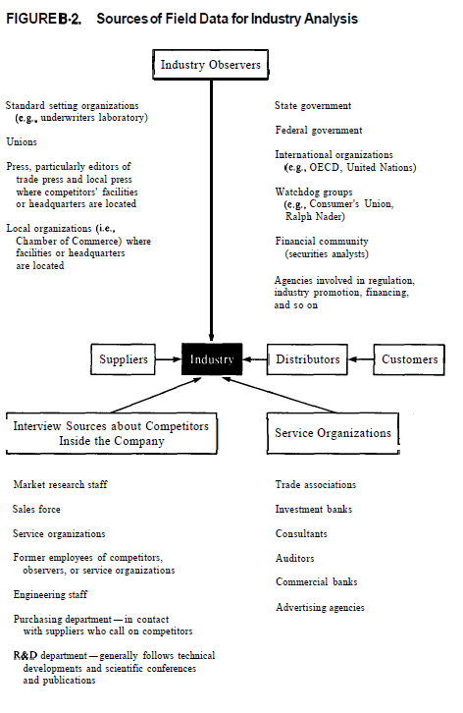
  + Field interviews
    - Contacts
    - Lead time
    - Quid pro quo
    - Affiliation
    - Perseverance
    - credibility
    - teamwork